Emergency First Response

Cycle of Care AB-CABS

- Check Quickly
  - Airway open?
  - Breathing normally?
- Unresponsive & Not Breathing Normally
  - Chest compressions
  - Airway open
  - Breath for Patient
  - Continue until help or AED arrives
- Responsive & Breathing normally
  - Serious bleeding
  - Shock
  - Spinal injury

9 skills of EFR Primary care (CPR)
- Scene assessment
- Barrier use
- Primary assessment
- CPR – chest compressions
- CPR – chest compressions combined with rescue breathing
- Option skill – AED use
- Serious bleeding management
- Shock management
- Spinal injury management
- Conscious/unconscious choking adult
- Option skill – emergency oxygen use orientation

4 skills of EFR Secondary Care (First Aid)
- Injury assessment
- Illness assessment
- Bandaging
- Splinting for dislocations and fractures

Learn what to do when Emergency Medical Services (EMS) are unavailable

Helping others in Need

Rendering Assistance
Render assistance immediately, chances of successful resuscitation diminish with time
Irreversible brain damage can occur within minutes

Three reasons to provide emergency care:
- Save or restore patient’s life
- Reduce patient’s recovery time in hospital or home
- Make difference between temporary and lifelong disability

Care First – patient has experienced submersion in water. CPR for a short time, then call EMS

Six reasons people hesitate to provide emergency care
- Anxiety
- Guilt
  - How you would feel if your help isn’t enough
- Feat of imperfect performance
  - Not hard to provide adequate care, which is always better than nothing
- Feat or making a person worse
  - Someone who’s not breathing with no heartbeat cannot become worse
- Fear of infection
- Responsibility concerns
  - Fear of lawsuit
  - Good Samaritan laws

Good Samaritan Laws
No legal duty to help a stranger in need
To guarantee protection under good Samaritan
- Only provide care within scope of training as emergency responder
- Ask for permission to help
- Act in good faith
- Don’t be reckless or negligent
- Act as a prudent person would
- Don’t abandon the patient once you begin care

Chain of help
- Early recognition and call for help
  - Scene assessment
  - Activate EMS call first
- Early CPR and cardiopulmonary resuscitation
  - Prolong window of time for defibrillation and provide small amount of blood flow to heart, brain, and other organs
- Early defibrillation
  - Chest compressions first
- Early professional care and follow-up

Permission to help – implied permission if patient is unresponsive

Emotional aspect of being an emergency responder
Relax after the incident
Avoid caffeine nicotine or alcohol
Talk to others about the incident
Spend time with others. Reach out
Leading a healthy Life
In many countries, more death from coronary heart disease than all other combined
- Avoid cigs
- Reduce and manage stress
- Avoid saturated, trans fat refined carbs and cholesterol
- Exercise regularly
- Keep up with treatment for conditions
- Learn to relax without becoming lethargic
- Manage stress, not just avoiding
- Take care of yourself

Bloodborne Pathogens
Hepatitis B & C
HIV

- Use gloves
- Use ventilation masks or face shields
- Use eye or face shields
- Wash hands after CPR

Recognizing Life-threatening problems
Heart attack
- Chest pain
- Pressure and squeezing
- Nausea, shortness of breath dizziness lightheadedness
- Sweat
- Faint
Cardiac arrest
- Heart stops receiving oxygen
- Quiver – ventricular fibrillation

Stroke
- Blood vessel blocks or ruptures in brain
- Deprives brain of oxygen and kills brain cells
- FAST
  - Face – ask to smile. Does one side droop
  - Arms – does one arm drift downwards when both asked to raised
  - Speech – simple phrase. Is speech slurred or strange
  - Time – call EMS immediately
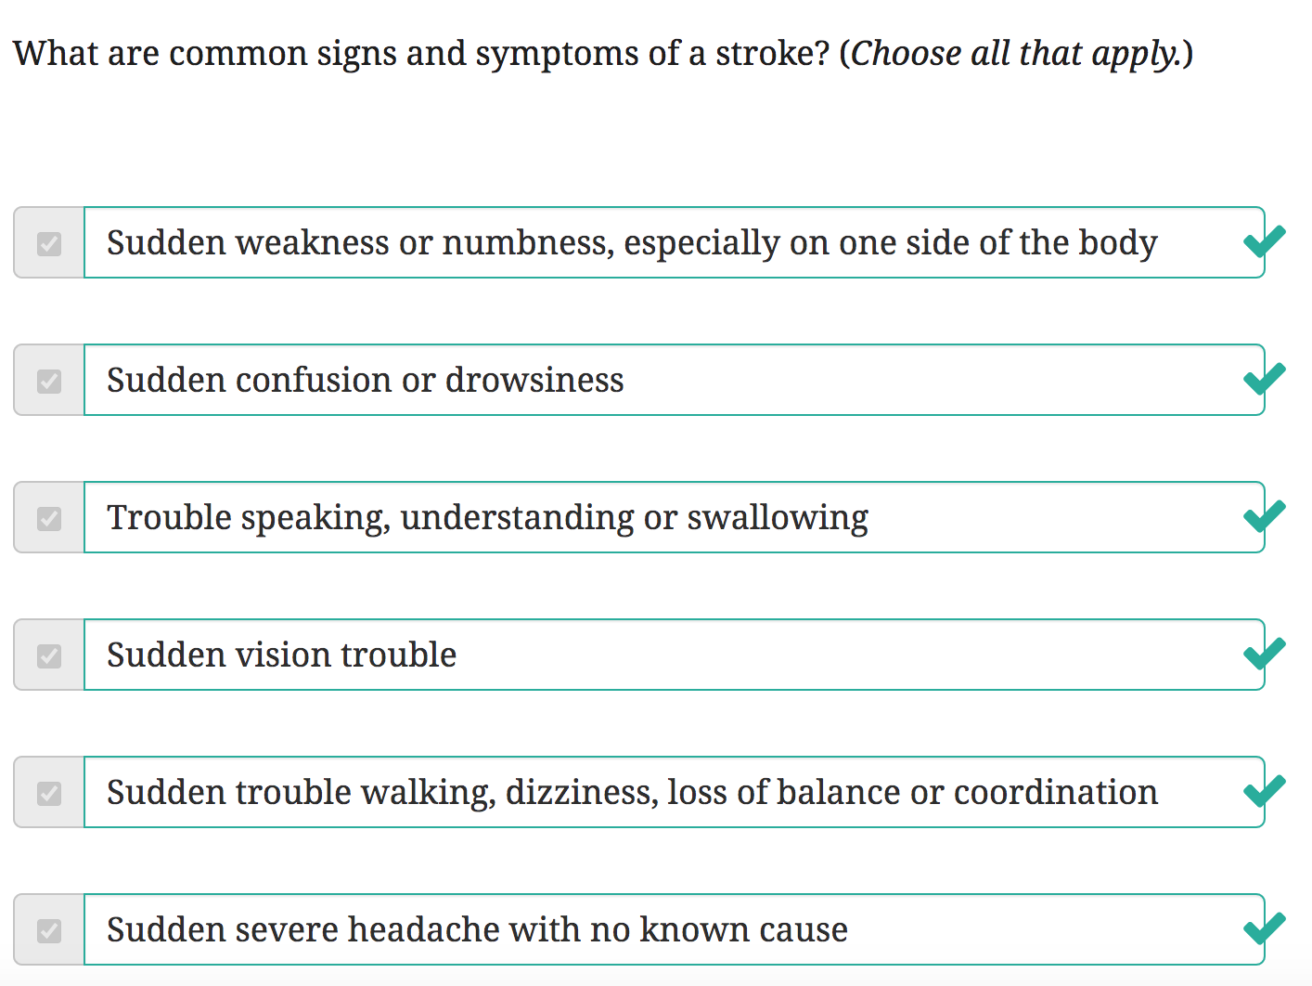

Airway Obstruction
- Choking on food
- Any other object
- Patient becomes embarrassed and leave
- Grab throat

CPR Definitions and Background
Primary – first & most important
CPR – Cardio Pulmonary Resuscitation

CPR is exhausting, rotate caregivers
Important to call EMR asap to limit CPR time

Rescue breathing
Air is 21% oxygen & we only use 5% of it with each breath. Plenty of remaining air to give to victim/patient

AB-CABS and Cycle of Care to Prioritize Primary Care

A – airway open
B – breathing normally
C – chest compressions
A – airway open
B – breathing for the patient
S – serious bleeding, Shock, Spinal Injury

First A also means Assess the scene and Apply Barriers

CPR takes priority over all other concerns

Importance of AED

Heartbeat is triggered by electrical impulses. When they malfunction, heart beats erratically. Called ventricular fibrillation (twitch)
AED will analyze for heart rhythm and apply the shock or advise if it’s a semi-automatic AED

Serious bleeding, shock, spinal injury
Bleeding
Even losing 1 of the 6 quarts of blood in the body is very dangerous

3 types of bleeding
- Arterial bleeding. Red blood spurts from a wound in rhythm with heartbeat. Most serious
- Venous bleeding. Dark red blood steadily flows from wound without rhythm
- Capillary bleeding. Blood oozes from wound. Can self heal

Shock
Blood can pool in an organ
Body begins to shut down
Indications
- Rapid weak pulse
- Pale or bluish tissue color
- Moist clammy skin & shivering
- Mental confusion anxiety restlessness or irritability
- Altered consciousness
- Nausea and vomiting
- Thirst
- Lackluster eyes, dazed look
- Shallow but rapid, labored breathing

Spinal Cord
Injury can result in paralysis or death
Higher up the worse

Signs of spinal injury
- Change of consciousness – fainting
- Difficulty breathing
- Vision problems
- Inability to move a body part
- Headache
- Vomiting
- Loss of balance
- Tingling or numbness in hands, fingers, and feet and/or toes
- Pain in back of neck area

Secondary Care (First Aid)
Second in sequence – less important
- Not life threatening

4 skills of EFR Secondary care
- Injury assessment
- Illness assessment
- Bandaging
- Splinting for dislocations and fractures

Injury v illness
- Injury is physical harm to body
- Illness is unhealthy condition of body

Sign – something you can see, hear, or feel
- Wounds bleeding discolorations deformities

Symptom – something patient tells you is wrong

Normal
- 12-20 breaths per minute
  - <8 or >24 per minute needs care
- 60-80 pulses per minute
- Skin is dry and warm to the touch
Assessment first aid is treatment of conditions that aren’t immediately life-threatening

Suspect Spinal Injury
- Penetration wound – gunshot
- Falling from height greater than own height
- Traffic or car accident
- Thrown out of a motorized vehicle
- Head first dive accident
- Lightning strike

Primary Care Skill 1: Scene Assessment

- STOP- Assess Scene
  - What caused injur
  - Potential hazards
  - Safe approach
  - Apply barriers
- THINK – Forumlate Safe Action Plan
  - Can you remain safe while helping? Your safety is first priority
  - What emergency care may be needed
  - How can activate local EMS
  - Think about training and relax
- ACT – begin providing care
  - AB-CABS

Primary Care Skill 2: Barrier Use

Goal – procedure for donning, removing, disposing gloves

Primary Care Skill 3: Primary Assessment

Goal
- Perform a patient responsiveness check w/ responder statement and tapping patient’s collarbone
- Check for open airway using tilt-chin lift or pistol grip lift
- Check for normal breathing
- Perform a Primary Assessment on a conscious and responsive patient.
- Perform a Primary Assessment on an unresponsive and unconscious patient.
- Place an unresponsive, breathing patient in the recovery position.
Responsive Patient
- Assess scene for dangers & check patient for responsiveness
- Verbal response means responsive, open airway, heartbeat, breathing. CPR not needed
- Alert EMS if appropriate
- Keep patient still unless safety is compromised
- Put on barriers if at hand
- Check for serious bleeding, shock, spinal injury management
- Cycle of Care

Unresponsive patient
- Assess scene for dangers & check patient for responsiveness
- Check for an open airway and normal breathing. Use head tilt-chin lift
- Lift chin to open airway
- Check for normal breathing. Look for chest movement and listen for breathing. Feel for air on your cheek
- If not responsiveness or breathing normally, ask bystander to call EMS and secure an AED if possible. Call First EMS if you’re alone
- Put on barriers if immediately at hand
- If unresponsive and not breathing normally, begin giving CPR
- If unresponsive but breathing normally, check for serious bleeding, shock, spinal injury
- If none is found, place patient in recovery position
  - Put them on their side
  - Change side every 30 minutes to relieve pressure

Primary Care Skill 4: Chest Compressions
Goal – perform adult CPR
- 100/120 chest compression per minute
  - Depress at least 5cm/2in

Primary Care Skill 5: Chest Compressions Combined with Rescue Breathing
Goal – perform adult complete CPR at ratio of 30 chest compressions to 2 rescue breaths

- Assess scene for dangers & check patient for responsiveness
- Verbal response means responsive, open airway, heartbeat, breathing. CPR not needed
- Alert EMS if appropriate
- Position patient on his back
- Locate compression site
  - Expose chest only if necessary to find the compression site
  - Between nipples
- Deliver chest compressions
  - 100 per minute
  - 30 compressions to 2 breaths
- Position a ventilation barrier
- Open patient’s airway
- Pinch nose closed
- Give two rescue breaths
  - Patient chest shoud rise
- Begin another 30 chest compressions
- Continue until
  - EMS arrives
  - AED
  - Patient responsive
  - Another Emergency responder takes over
  - Too exhausted to continue

Primary Care Skill 6: Serious Bleeding Management
Direct Pressure
- Give ER statement, access scene, alert EMS, open airway
- Put on barriers
- Place clean cloth or sterile dressing (or hand) over wound and apply sustained pressure
- Release pressure to check status of bleeding
Pressure Bandage
- Place pressure bandage over sterile dressing
- If bandage soaked, place another clean cloth or dressing on top and keep bandage in place
- Continue to apply direct pressure to wound
- Don’t remove blood-soaked bandages bc blood clots in dressing help control bleeding
- Bandage tightly

Primary Care Skill 7: Shock Management
Goal – manage shock my conducting a primary assessment, protecting the patient, and stabilizing the head

- Treat injured, unresponsive, or unconscious patient in the position found. Don’t move if possible
- Hold patients head to keep neck in place
- Maintain body temperature
- If no spinal injuries or leg fractures, elevate legs 6-12 inches to allow blood to heart

Primary Care Skill 8: Spinal Injury Management
Goal- demonstrate how to manage a suspected spinal injury by conducting a primary assessment, protecting patient and patient’s head
- Log roll to minimize spine and neck movement

Responsive and breathing
- Stabilize head
- Instruct patient to remain still & call EMS

Unresponsive
- Patient must be on back
  - If on back, use tilt-chin method to open airway
  - If not on back, use log roll to reposition
- Perform log roll by self
  - Keep neck, head, and back in line and hold them firm as roll
- If there’s help, perform a two person log roll

Primary Care Skill 9: Conscious/Unconscious Choking Adult

Goal – assist patient with airway obstruction
- Help patient to the ground
- Activate EMS
- Begin CPR
- Following compressions, check mouth and remove any obstructions
- Once clear, proceed with 2 rescue breaths
- Continue CPR until obstruction is relieved or EMS arrives

Secondary Care Skill 1: Injury Assessment

Goal – demonstrate how to conduct a head-to-toe injury assessment on a patient and note injuries to report to EMS personnel

- Deliver responder statement, asking permission to assist. Explain your assessment. Place gloves
- Stabilize patient’s head, ask questions, don’t allow head to move
- Stop assessment if patient complains of spinal, neck, or head pain. Continue to stabilize & end assessment until EMS arrives
- Start assessment at head and work down body
- Feel for deformities by gently running fingers over
- Check ears and nose for blood or fluid. If found, end assessment and suspect head injury
- Have patient track finer with eyes
- Feel skull and neck for abnormalities, stop if complaint
- Gently push inwards on shoulder blades
- Press shoulders inwards
- Run two fingers over collarbones from shoulders to center
- Stabilize shoulder and run hand down arm. Ask patient to wiggle fingers and squeeze hand
- Inspect chest ofr deformatiy
- Feel spinal column
- Feel abdomen
- Check hipbones for swelling or hardness, unusual mass, tenderness, deformities. Don’t push inwards
- Run down each thigh from top to bottom. Ask patient to wiggle toes
- Note pain or abnormalities to EMS. Monitor with Cycle of Care.

Secondary Care Skill 2: Illness assessment

Goal – demonstrage how to conduct illness assessment by
- Asking patient how feel and medical history
- Check breathing, pulse, temperature, moisture, color
- Report to EMS

SAMPLE – Signs and Symptoms

Signs and Symptoms, Allergies, Medications, Preexisting medical history, Last meal & Events

- Ask patient how they feel and what occurred before illness
  - How do you feel now
  - What were you doing when you began to feel sick
  - When did symptoms first occur
  - Where were you when first symptoms occurred
- Find a pulse
  - Locate adam’s apple with index and middle fingers
  - Slide fingers down into the groove of neck on close side
- Check radial artery for pulse
  - Slide 2-3 fingers below wrist
- Can pulse be described as rapid, strong, or weak
- Look for signs and symptoms of respiratory distress, including
  - Wheezing, gurgling, high pitched noises
  - Complaints of shortness of breath, dizzy, lightheaded
  - Chest pain, numbness or tingling in arms or legs
- Count breath rate
  - Watch chest rise and fall
  - Place hand on abdomen
- Determine whether respirations may be described as fast, slow, labored, wheezing, or gasping
- Feel patient’s forehead or cheek with back of hand
  - Compare with own temperature
  - Ask if patient has been exercising
- Determine if skin is warm, hot, cool, moist, clammy, etc
- Look for skin color changes: extremely pale, ashen, red, blue, yellowish, black & blue
- If patient is dark, check nail beds, gums, tongue, palms, white of eyes, ear lobes

SAMPLE – Allergies
- Ask if patient has allergies
- Ingested anything they might be allergic to? Bit or stung
- Treat severe reactions as a medical emergency and follow primary care procedures
- Anaphylaxis can be treated by epinephrine (adrenaline)
- Second dose of epinephrine can be applied

SAMPLE – Medications
- Ask if patient uses medications
- Collect all info and prescribing doctor’s name

SAMPLE – Preexisting Medical Conditions
- Ask if preexisting medical condition

SAMPLE – Last Meal
- Ask last meal and when
- Drugs or alcohol

SAMPLE – Events
- Note events leading up to illness

Secondary Care Skill 3: Bandaging

- Put on gloves
- Apply bandage over sterile dressing covering the wound
- Apply bandage below wound and work upward toward the heart
- Wrap roller bandage firmly and consistently
- Secure end of bandage by tucking or taping up in place
- With foot, secure the ankle with bandage
- With hand, secure using the thumbg and wrist
- With elbow, bandage below and above joint
- With knee, bandage below and above joint
- If impaled, bandage in place and don’t remove

Using triangular bandages
- Use to support upper arm, ribs, or shoulder
- Place top of bandage over the shoulder
- Bend arm at the elbow, bring forearm across chest and over bandage
- Bring lower end of the bandage over the opposite shoulder and tie off at the back of the neck.
- Tie off triangular bandage at the patient’s elbow, locking the arm in the sling.
- When broken ribs are suspected, use a second triangular bandage to hold the arm against the injured side of the chest. Simply tie bandage over the sling and around the chest

Secondary Care Skill 4: Splinting for dislocations and fractures
- Choose a splint long enough to immobilize joint above and below injury
- If rigid splint, apply ample padding
- Bandage splint in place using a roller bandage, an elastic bandage, adhesive tape or other available material
- Always check circulation before and after splinting. If pulse is absent, loosen the splint until the pulse returns. To do this, look for color of tissue in fingernails and toenails.
- If the fracture is in the upper arm, place arm in sling after splinting.

